SCUBA-2 Block Specification
rx_control

February 15, 2005
Table of Contents

1. Block Overview 3
1.1 Block Location and Block Interface Within System 3
1.2 Block Functionality / Features 3
1.3 Block Dataflow 3
2. Block Interfaces 4
2.1 Interface Signal Description 4
2.2 Interface Protocol and Timing 4
3. High-Level Description 5
3.1 Block Description 5
4. Files of the Block 6
4.1 Source Code 6
4.1.1 rx_control.vhd 6

Block Overview

Block Location and Block Interface Within System
This block is located on the clock card FPGA. It interfaces with the following block on the clock card:

- rx_fifo

Block Functionality / Features
- This block controls the writing of incoming data from the Cypress CY7B933 HOTLinkTM receiver (located on the clock card) to a FIFO block (rx_fifo) on the clock card FPGA.

Block Dataflow

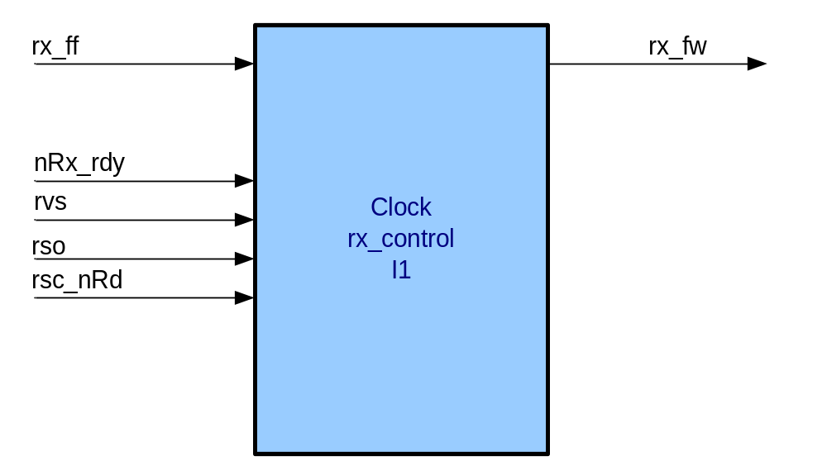

Block Interfaces

Interface Signal Description
- Interface Signals
Signal | Description | Direction
Control Signals |  | in
rx_ff | Receive FIFO full line. Indicates that the FIFO is full and cannot be written to. | in
nRx_rdy | HOTLinkTM Receiver Data Output Ready. A LOW pulse indicates that new data has been received and is ready to be delivered. See CY7B933 data sheet for details. | in
rvs | HOTLinkTM Receiver Violation Symbol. A HIGH indicates that a code rule violation has been detected. See CY7B933 data sheet for details. | in
rso | HOTLinkTM Receiver Status Out. See CY7B933 data sheet for details. | in
rsc_nRd | HOTLinkTM receiver Special Character / not data. This line indicates the context of the received data. HIGH indicates a control special character code (such as idle packets). LOW indicates a Data character. See CY7B933 data sheet for further details. | in
rx_fw | FIFO write request. When asserted data on FIFO input written to FIFO. | out

Interface Protocol and Timing

igh-Level Description

Block Description

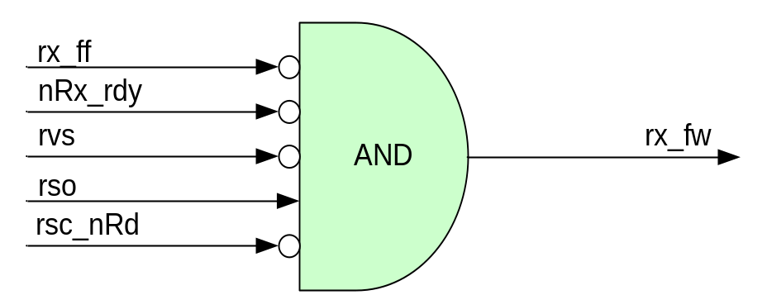

Files of the Block

Source Code

rx_control.vhd

